**Developing an AI Model for Inventory Prediction and Warehouse Distribution Optimization**

1. **Introduction:**

Inventory management and warehouse distribution are critical components of supply chain operations in various industries, including e-commerce. This technical documentation outlines the process of developing an AI model to predict inventory demand and optimize warehouse distribution, leveraging machine learning techniques.

2. **Problem Statement:**

The primary objective is to accurately forecast future demand for products and optimize their distribution across warehouses. This involves:

- Predicting future inventory demand based on historical data.

- Optimizing warehouse distribution to minimize costs and enhance efficiency.

3. **Data Collection and Preprocessing:**

- Gather historical data including product sales, inventory levels, order frequency, and warehouse locations.

- Preprocess data by handling missing values, outliers, and categorical variables.

- Engineer features such as time-based trends, seasonality, and geographical factors.

4. **Model Selection:**

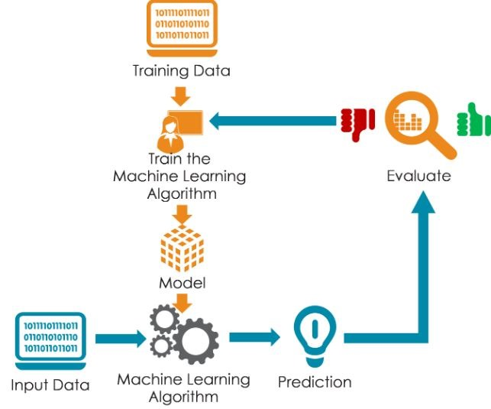

- Experiment with various machine learning algorithms suitable for time-series forecasting and optimization tasks.

- Consider algorithms like ARIMA, Prophet, LSTM for demand forecasting, and techniques like linear programming for warehouse optimization.

- Select the most suitable model based on performance metrics and computational efficiency.

5. **Model Training:**

- Split the preprocessed dataset into training and validation sets.

- Train the selected models using historical data, with features including product demand, inventory levels, and warehouse capacities.

- Fine-tune hyperparameters to optimize model performance.

6. **Model Evaluation:**

- Evaluate model performance using appropriate metrics such as Mean Absolute Error (MAE), Mean Squared Error (MSE), or Root Mean Squared Error (RMSE) for demand forecasting.

- For warehouse distribution optimization, assess metrics like total cost, transportation efficiency, and warehouse utilization.

7. **Integration and Deployment:**

- Integrate the trained models into the existing inventory management and warehouse distribution systems.

- Develop APIs or interfaces for seamless communication between the AI model and other systems.

- Conduct thorough testing to ensure the robustness and reliability of the integrated solution.

8. **Monitoring and Maintenance:**

- Implement monitoring mechanisms to track model performance and detect anomalies in demand patterns or warehouse operations.

- Regularly update the model with new data to adapt to changing market dynamics and business requirements.

- Conduct periodic maintenance to address any issues or improvements identified during monitoring.

9. **Conclusion:**

Developing an AI model for inventory prediction and warehouse distribution optimization is a complex yet essential endeavor for modern supply chain management. By leveraging advanced machine learning techniques, businesses can enhance efficiency, minimize costs, and improve customer satisfaction in an increasingly competitive market landscape.